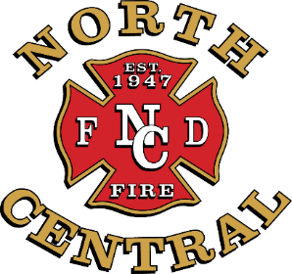
NORTH CENTRAL FIRE PROTECTION DISTRICT
Board of Directors: Ken Abrahamian • Michael Foglio
Michael Golden • Rusty Nonini • Amanda Souza
Fire Chief: Timothy V. Henry, CFO, EFO

Fire Headquarters
15850 W. Kearney Boulevard
Kerman, California 93630-9335
(559) 878-4550 • FAX (559) 846-3788
www.northcentralfire.org

PUBLIC NOTICE
NOTICE TO CONSIDER PROPOSALS FOR
CDBG GRANT FUNDS
The North Central Fire Protection District Board of Directors will hold a public hearing to consider projects that could be financed by the Federal Community Development Block Grant (CDBG) Program. The project the District is considering is the purchase of a new Water Tender for the District’s Fire Station in Biola.
The meeting will be held on August 25, 2022, at 5:30 p.m. at the Kerman fire station conference room located at 15850 W. Kearney Blvd., Kerman, California. Anyone wishing to address the Board can do so by written communication or in person during a Board of Directors meeting. Interested individuals and organizations are encouraged to attend to voice project recommendations for their community and neighborhood. Community support for such projects is an important part of receiving CDBG grant funding.
The CDBG is a Federal grant program administered by Fresno County to address housing and community development needs of low-and-moderate income persons. Types of eligible projects include (public works improvements such as water, sewer, streets and drainage, fire protection facilities and equipment, solid waste facilities, libraries and community centers.)
For further information, please contact the North Central Fire Protection District at (559) 878-4550 or the Fresno County Community Development office at (559) 600-4292

Dated: August 12, 2022
/s/Timothy V. Henry
Fire Chief
North Central Fire Protection District

